***Proposed New Pipeline***

***Through Pittsylvania County, VA and NC Counties***

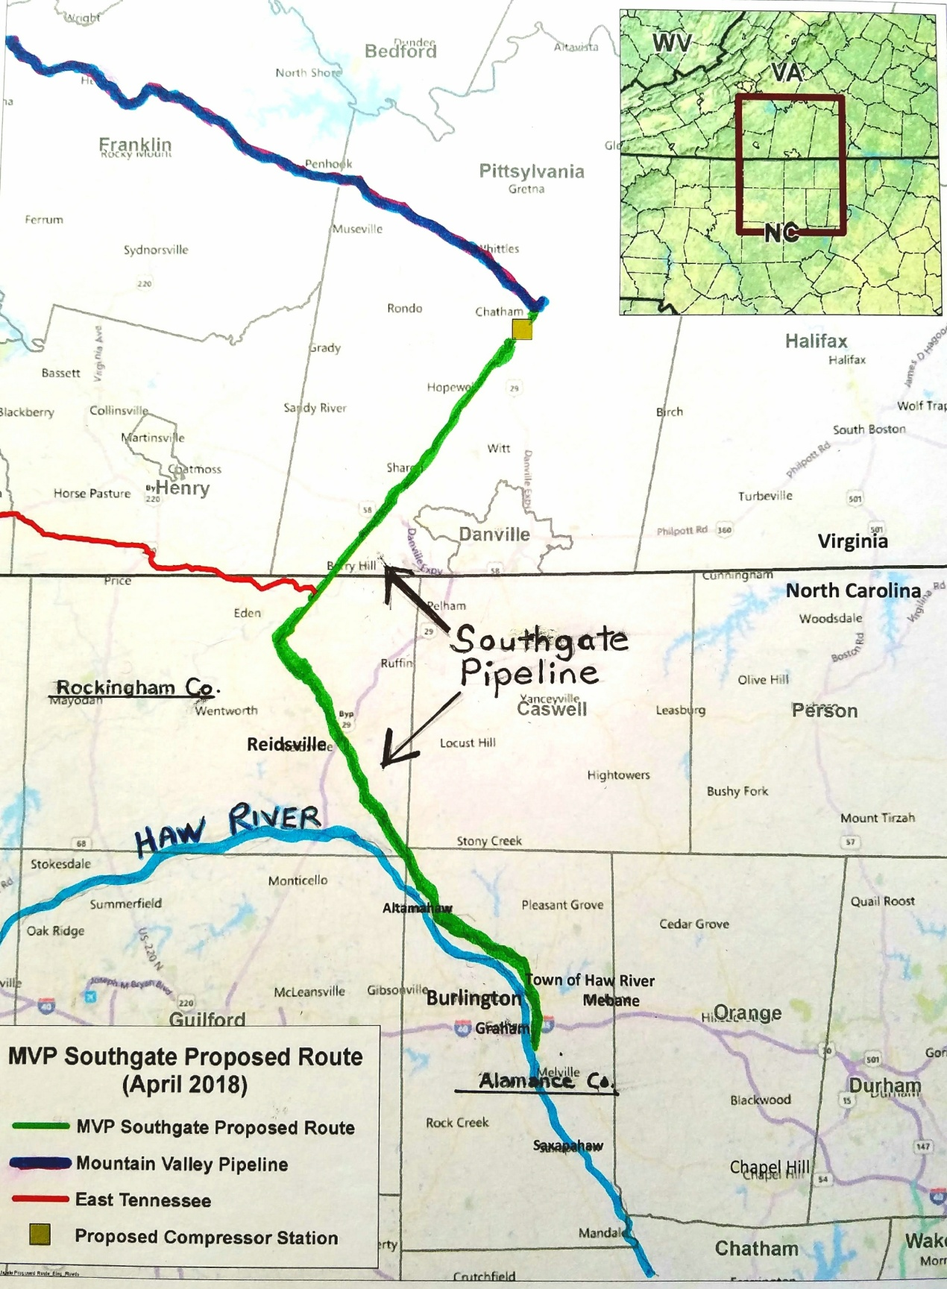

**Join Us!**

**Learn more about the pipeline and how we can organize to fight it.**

**Let's work together to protect our waters, land, and communities.**



**End Point**

**Start Point**

**Mountain Valley Pipeline Southgate would be a new 72-mile pipeline bringing fracked gas from WVA into NC.**

**It would cut through land from Reidsville down along the east side of Burlington, to end near**

**I-85/40 east of Graham.**

**What Would Be**

**The Impacts?**

**Health and Safety Hazards** including pipeline leaks, explosions, and public health hazards due to compressor station emissions.

**Abuse of Property Rights** through minimal compensation or use of eminent domain, and destruction of forest and farmland.

**Damage to streams and wetlands,** where the pipeline crosses, and from construction sediment.

**Methane emissions,** from pipeline leaks and compressor station willcontribute toclimate change.

**Appvoices.org**

**For more information contact**

**Lara Mack: 540-246-9720, lara@appvoices.org**